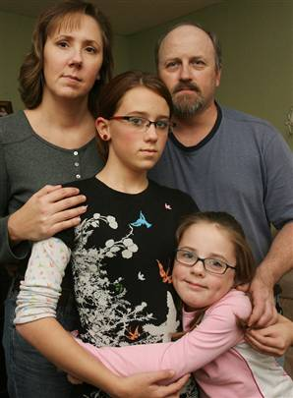

Eighth-grader Megan Coulter gets a family hug from her mother Melissa Coulter, left, father Dean Coulter, right, and sister Baylee, bottom, on Monday.

